**KV IIM LUCKNOW**

**CLASS: X SUBJECT : MATHS**

**PRACTICE PAPER 2019**

**Maximum Marks: 80 Time Allowed: 3 hours**

**General Instructions:**

a. All questions are compulsory

b. The question paper consists of 40 questions divided into four sections A, B, C & D.

c. Section A comprises of 20 questions of 1 mark each.

Section B comprises of 6 questions of 2 marks each.

Section C comprises of 8 questions of 3 marks each.

Section D comprises 6 questions of 4 marks each

**Section A**

1. For every natural number ‘n’, 6n always ends with the digit

a. 4 b. 8 c. 6 d. 0

2. If HCF(72, 120) = 24, then LCM(72, 120) is

a. 2880 b. 240 c. 1728 d. 360

3. Which of the following is not a rational number?

√8,√9 ,√16,√25

a. √25 b. √16 c. √8 d. √9

4. If O is the centre of a circle, PQ is a chord and tangent PR at P makes an angle of60⁰ with PQ, then

$∟$ POQ is equal to

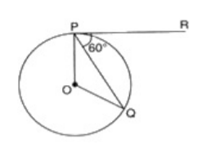

a. 110° b. 120° c. 100° d. 90°

5. A real number ‘k’ is said to be a zero of a polynomial p(x), if p(k) =

a. 0 b. 2 c. 3 d. 1

6. A polynomial whose sum and product of zeroes are – 4 and 3 is

a. $x^{2}$ +4x+3 b. $x^{2}$-4x+3 c. $x^{2}$-4x-3 d. None of these

7. Fill in the blanks:

Three points are said to be collinear, if area of triangle formed by these points is ________.

8. Fill in the blanks:

The equation axn + byn + c = 0 represents a straight line if 'n' = ________.

9.Fill in the blanks:

A system of two linear equations in two variables has no solution, if their graphs _____________ at any point.

10.The distance of a point from the x – axis is called

a. None of these b. origin c. abscissa d. ordinate

11. If the co – ordinates of a point are ( – 5, 11), then its abscissa is

a. – 5 b. 11 c. 5 d. – 11

12. Fill in the blanks:

The value of sin $θ$ cos , for = 30o is ________.

13. Fill in the blanks: If A and B are acute angles and sin A = cos B, then the value of (A + B) is ________.

14. Fill in the blanks:

Two polygons of the same number of sides are similar, if their corresponding angles are ________ and their corresponding sides are ________.

15. Write the value of sin $θ$ cos(90° - $θ$) + cos $θ$ sin (90° - $θ$).

16.Solve: 2cos=1

17. Find the radius of a circle whose circumference is equal to the sum of the circumference of two circles of diameter 36 cm and 20 cm.

18.Find the common difference of the A.P whose first term is 12 and fifth term is 0.

19. If the perimeter and the area of a circle are numerically equal, then Find the radius of the circle.

20. Find the number of zeroes of p(x)

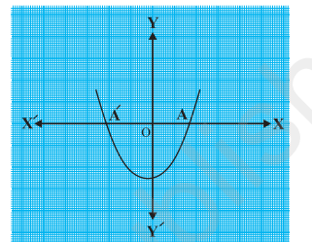

**SECTION –B**

21. Two concentric circles are of radii 5 cm and 3 cm. Find the length of the chord of the larger circle which touches the smaller circle.

22. If sin A = calculate cos A and tan A.

23. If sin (A – B) = , cos (A + B) = $\frac{1}{2}$ 0° < A + B ≤ 90°, A > B, find A and B.

24. Find the area of a quadrant of a circle whose circumference is 22 cm..

25. Divide 2x2 + 3x + 1 by x + 2.

26. Find the nature of the roots of the quadratic equation 2x2 – 3x + 5 = 0.

**SECTIONC**

27.Quadratic polynomial 2x2 - 3x + 1 has zeroes as $α$ and $β$. Now form a quadratic polynomial whose zeroes are 3 and 3 .

28. Draw a pair of tangents to a circle of radius 3 cm which are inclined to each other at angle of 60°.

29. Construct a triangle ABC in which AB = 5 cm, BC = 6 cm and AC = 7 cm. Construct another triangle similar to triangle ABC such that its sides are $\frac{3}{5}$ of the corresponding sides of ABC.

30. Prove that sec A (1 – sin A)(sec A + tan A) = 1.

31. Use Euclid's division algorithm to find the HCF of 184, 230 and 276.

**OR**  Prove that 3 + $\sqrt{5}$ is an irrational number.

32. Prove that the parallelogram circumscribing a circle is a rhombus.

33. Two brothers Ramesh and Pulkit were at home and have to reach School. Ramesh went to Library first to return a book and then reaches School directly whereas Pulkit went to Skate Park first to meet his friend and then reaches School directly.

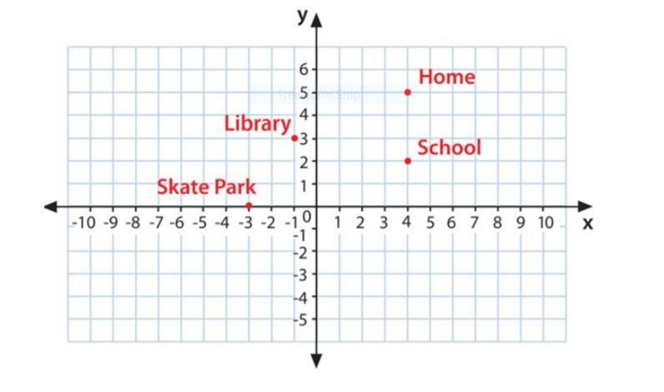

1. How far is School from their Home?

(ii). What is the extra distance travelled by Ramesh in reaching his School? (All distances are measured in metres as straight lines)

34 Check whether the pair of equations x + 3y = 6 and 2x – 3y = 12 is consistent. If so, solve them graphically.

**SECTION-D**

35. A train takes 2 hours less for a journey of 300 km if its speed is increased by 5 km/hr from its usual speed. Find the usual speed of the train.

36. On a horizontal plane there is a vertical tower with a flag pole on the top of the tower. At a point 9 metres away from the foot of the tower the angle of elevation of the top and bottom of the flag pole are 60° and 30° respectively. Find the height of the tower and the flag pole mounted on it

37. Find the area of the shaded region in Fig. where a circular arc of radius 6 cm has been drawn with vertex O of an equilateral triangle OAB of side 12 cm as centre.

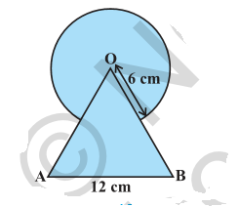

**OR**

From each corner of a square of side 4 cm a quadrant of a circle of radius 1 cm is cut and also a circle of diameter 2 cm is cut as shown in Fig. Find the area of the remaining portion of the square.

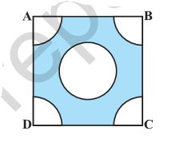

38. Prove that The ratio of the areas of two similar triangles is equal to the square of the ratio of the.

39. In an equilateral triangle, prove that three times the square of one side is equal to four times the square of one of its altitudes.ir corresponding sides.

40. How many terms of the AP : 24, 21, 18, . . . must be taken so that their sum is 78?

**OR**

The first term of an AP is 5, the last term is 45 and the sum is 400. Find the number of terms and the common difference.